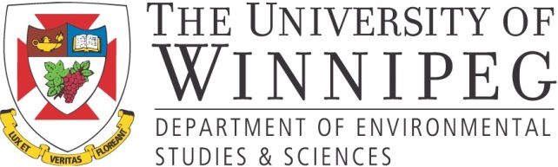
FOR IMMEDIATE RELEASE
PRESS RELEASE
New Research Partnership to Shed Light on Aboriginal Business Views of Bioenergy Development
January 26. 2017, Toronto ON: The University of Winnipeg’s (UW) Centre for Forest Interdisciplinary Research (C-FIR), Canadian Council for Aboriginal Business (CCAB), and University of Alberta have initiated a new biomass energy innovation project. In addition, to support from the main partners, the research is supported by a new ~20K grant from BioFuelNet Canada (BFN), which is part of Canada’s Networks of Centres of Excellence program.
The study will provide a benchmark for better understanding perceptions held by those in the Aboriginal business community, improve awareness of biomass opportunities and issues, and help identify preferences for involvement in the bioenergy sector. Led by Dr. Ryan Bullock (UW), Dr. John Parkins, (Alberta), and CCAB Director of Research and Government Relations, Mr. Max Skudra, the project will benefit students by creating a new internship with CCAB and research opportunities for UW students.
“This project will advance understanding of the views held by decision makers in the Aboriginal business community, many of whom are already partners in bioenergy initiatives and can help improve program and policy initiatives,” says Dr. Ryan Bullock, C-FIR Director and Assistant Professor with the Department of Environmental Studies and Sciences at UW. “We expect the findings to be strategically important for Aboriginal firms, economic developers, and policy makers.”

According to Jean Paul Rene Joseph Gladu, President and CEO for CCAB, “no recent research has been done to analyze the perspectives of Aboriginal business people who have the capability to advance projects. We will help to address this gap by examining their attitudes about biomass energy innovation and identifying workable policy and communicative process solutions.”
A comprehensive report for this one year study will share findings and policy recommendations.

-30-

For additional information or to set-up an interview, please contact:

Stella Nesca, Marketing & Communications Liaison, CCAB, 416-961-8663 Ext. 224 or snesca@ccab.com
Naniece Ibrahim, Communications Officer, The University of Winnipeg, 204-988-7130 or n.ibrahim@uwinnipeg.ca

About CCAB
The CCAB is committed to the full participation of Canada’s Aboriginal peoples in Canada’s economy. A national non-profit, non-partisan association, CCAB offers knowledge, resources, and programs to both Aboriginal and non-Aboriginal-owned companies that foster economic opportunities for Aboriginal peoples and businesses across Canada.

About C-FIR
C-FIR is dedicated to the development of interdisciplinary research, education, and training in the areas of forestry, forest ecosystems, forest values, and the human uses of forests. Established in 1999, C-FIR focuses on understanding the evolution of today’s forests alongside societal values and uses past and present information to assist in understanding future changes and impacts to the region’s forests, economies, and communities.
About BioFuelNet Canada
BioFuelNet Canada is a network that brings together the Canadian biofuels research community to address the challenges impeding the growth of an advanced biofuels industry, while focusing on non-food biomass as biofuel feedstocks. BioFuelNet aims to catalyze the expansion of Canada’s bioeconomy by creating a national network to drive the commercialization of advanced biofuels and bioproducts through integrated research, innovation, smart policy and strategic partnerships.

