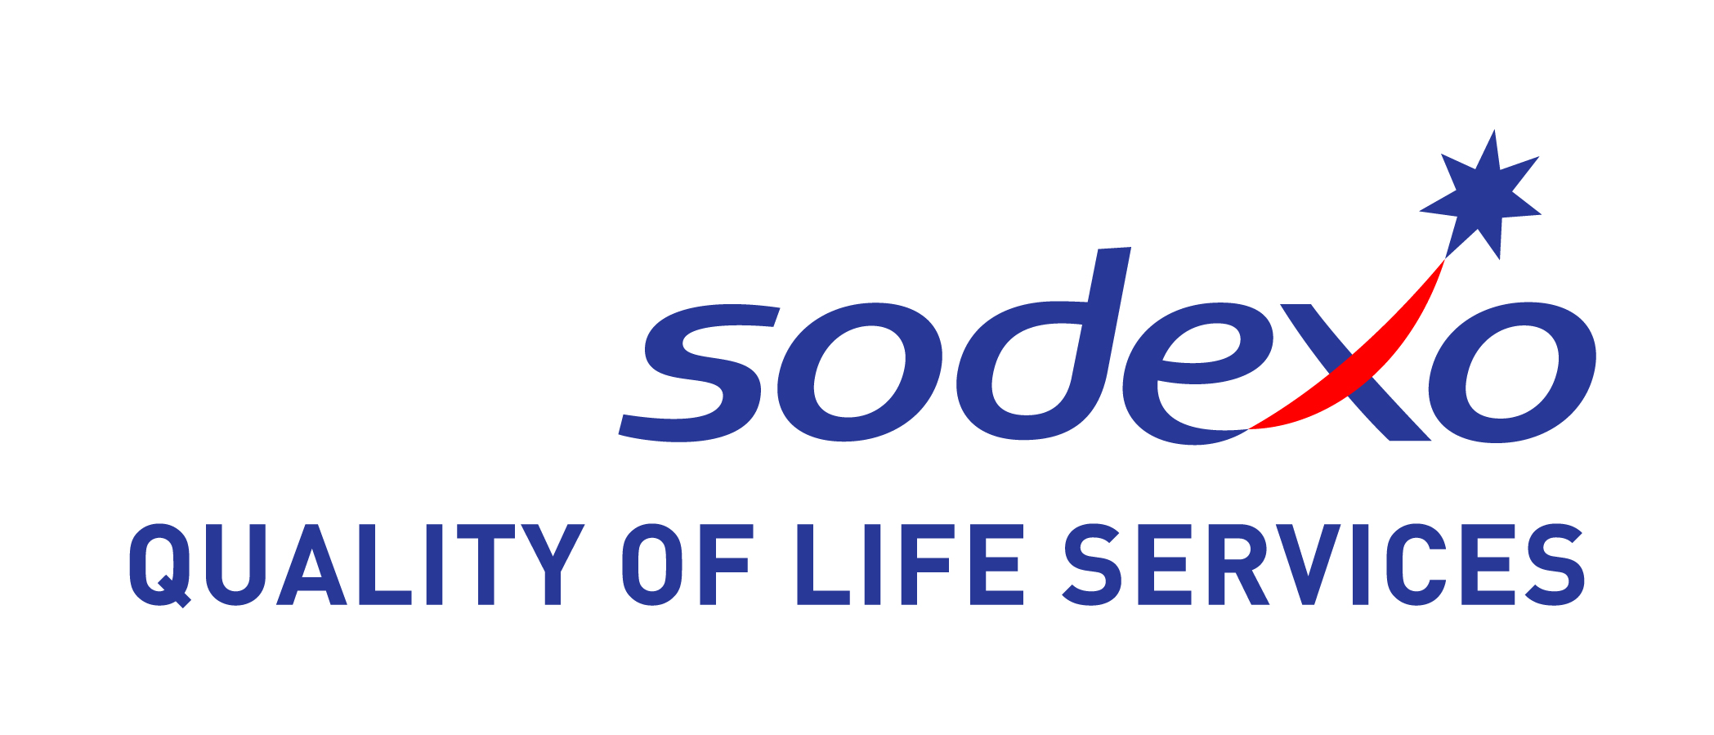

Membertou’s impressive economic stewardship clinches inaugural award
celebrating Aboriginal economic development in Canada

Toronto, ON – March 19, 2014 –The Canadian Council for Aboriginal Business (CCAB) and Sodexo Canada are pleased to announce the Membertou Development Corporation as the inaugural winner of the Aboriginal Economic Development Corporation (AEDC) Award for 2014.

Membertou is situated three kilometers from downtown Sydney Nova Scotia and is one of five Mi’kmaw communities in Cape Breton. The First Nation has a population of over 1260.

The community of Membertou successfully overcame the significant challenges facing an urban First Nation community. In a two-decade span from 1995-2014, Membertou First Nation lifted itself from a poor community with low morale and a high unemployment rate to a very strong community within a community that has seen progress, economic growth and a commitment to its culture and heritage.

The path to economic success was made possible through three strategic decisions.

- Membertou actively forged a new economic frontier for its people, one that built on the innovations of today while at the same time, incorporated indigenous knowledge-based principles of conservation, sustainability of resources and reverence for the land and the waters.

- The Membertou Development Corporation increased its profile with major private sector companies by launching the Membertou Corporate Office in downtown Halifax and forming lucrative partnerships across a diversity of private industry sectors.

- Membertou initiated education and career training programs for its residents in order to maximize employment opportunities within the newly forged business partnerships and initiatives.

The opportunities flowing from these decisions continue to build momentum for Membertou’s financial independence and self-sustainability.

“Congratulations to Membertou for such impressive economic stewardship,” said CCAB President and CEO JP Gladu. “This new award will become the barometer of Aboriginal business growth and success around the world. After a hiatus of over 200 years, Aboriginal business is back and growing through diversification and investment that encourages entrepreneurial spirit and prosperity for all Canadians.”

The CCAB would like to recognize and thank Sodexo Canada the founding and exclusive sponsor for the Aboriginal Economic Development Corporation (AEDC) of the Year Award.

Sodexo is proud to be celebrated as one of the top diversity employers in Canada and a Progressive Aboriginal Relations (PAR) Gold Certified company. Quality of Life is central to the performance and growth of individuals and organizations. Working from this perspective, Sodexo has redefined how to best serve its clients’ complex needs. It is dedicated to improving the quality of life for individuals and organizations wherever they work.

“Sincere congratulations to the Membertou Development Corporation for this honour,” says Dean Johnson, President of Sodexo Canada. “When we speak about quality of life we see this exciting new award as an opportunity to celebrate the economic well-being and sustainability that Aboriginal Development Corporations bring to their communities.”

The Membertou Development Corporation was successful in diversifying its economy, including becoming ISO 9001 certified and creating a convention centre, gaming centre, business centre and many other investments within the community. The most recent addition is the Hampton Inn by Hilton Membertou, which opened in 2012.

Over the last ten years under the leadership of Chief Terrance Paul the Membertou Band has gone from 37 employees on a $4 million budget and a deficit of $1 million to a current 550 employees on a $112 million budget and zero deficit

About the award
The AECD award is the first of its kind in Canada and is designed to shine a light on the important role that Aboriginal corporations are playing in boardrooms and First Nation, Inuit and Métis communities across the country.

The Canadian Council for Aboriginal Business’ Aboriginal Economic Development Corporation of the Year Award will be presented by Sodexo at the Annual Calgary Gala on Tuesday May 13th at the Hyatt Regency.

About the Canadian Council for Aboriginal Business (CCAB):
CCAB is committed to the full participation of Aboriginal people in Canada’s economy. A national non-profit, non-partisan association, CCAB offers knowledge, resources, and programs to both mainstream and Aboriginal owned companies that foster economic opportunities for Aboriginal people and businesses across Canada.

About Sodexo in Canada
Sodexo has been delivering On-Site Services in Canada for over 40 years. Recognized as a strategic partner, Sodexo Canada has consolidated its position by providing a range of Quality of Life Services for clients, their employees and visitors in the corporate, education, healthcare and remote sites segments. Delivering food and facilities management services for over 200 clients, Sodexo is a market leader in Canada in terms of revenue and consumers served, and has been recognized as a top employer for the past four consecutive years. Sodexo Canada is proud to have created the Sodexo Foundation, an independent charitable organization that has donated more than 1 million meals to at risk youth in Canada since it was founded in 2000.
Event Inquiries:
For more information on the CCAB’s Annual Calgary Gala, please contact Maya Kwasnycia, Senior Manager, Sponsorship & Events, mkwasnycia@ccab.com or 416 961 8663 ext.224

Media Inquiries:
Katherine Power
Vice President, Communications, Sodexo Canada
Mob: 289-439-9170
katherine.power@sodexo.com

Chris Allicock, Amberlight Productions
(416) 694-3131/ Cell (416) 319-8003
callicock@amberlight.ca

