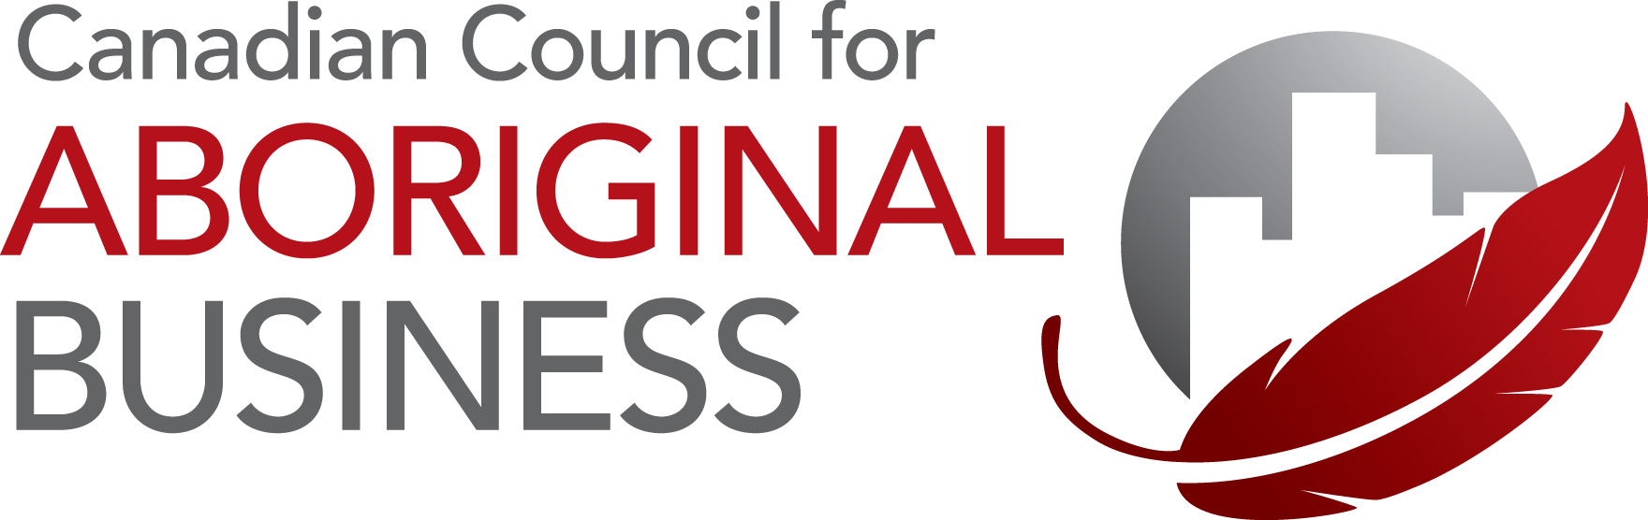

Member Roundtable – Community Relations, April 5th, 2012

Learn how Aboriginal communities and mining companies in northern Ontario are building sustainable relationships. Discover key success factors and managing relationships from two leading mining companies and an Aboriginal community proponent. Explore issues and share experiences at a CCAB facilitated roundtable discussion.

Agenda (EDT)

1:30 - 1:45
- Introductions by Clint Davis, President & CEO, Canadian Council for Aboriginal Business
- Welcome by Sandra Larin, Director – VP, Global Treasury Management, BMO Capital Markets

1:45 - 3:15
Panel Presentation and Q&A
- Michael Fox, President, Fox High Impact Consulting
- Glenn Nolan, Vice President Aboriginal Affairs, Noront Resources Ltd.
- Derek Teevan, Vice President Aboriginal and Government Affairs, Detour Gold

3:15 - 3:30
Break

3:30 - 4:30
Roundtable Discussion

Panelists Topics

Michael Fox ~ Understanding the interests and expectations of the community in resource development; – how the challenges in communities influence the interests and expectations of First Nations leaders when faced with opportunities of resource development.

Glenn Nolan ~ Listen, Learn and Leverage: How following these three words bring about a trusting and lasting relationship between companies and communities.

Derek Teevan ~ Getting community relations right – it’s never easy and takes more time, money and energy than you think. Derek Teevan will outline the benefits of early engagement, the importance of sustained community involvement and communication with membership along with documenting and celebrating the community-corporate successes.

Panelist Biographies
Michael Fox, President, Fox High Impact Consulting

Michael Fox is the President of Fox High Impact Consulting, a national firm that specializes in Aboriginal processes, participation, and partnership development in the energy and mineral sectors. He brings a wealth of experience in structuring projects, partnership, and financing from early stage engagement through later stage formal consultation with First Nations. In his previous employment, he assisted northern Ontario First Nations with economic development initiatives within the main natural resource development sectors of Ontario: forestry, energy, and mining. He has facilitated joint ventures and partnership arrangements between First Nations and industry. In addition, he has acted as one of key liaison person between First Nations' project proponents and governmental agencies as well as facilitated capacity building initiatives. He obtained a post-secondary education in business administration and an honours degree in political science, with the latter being primarily focused on natural resource development in Ontario and Aboriginal law. He's originally from Weenusk First Nation and is happily married with twin boys and a daughter.

Glenn Nolan, Vice President, Aboriginal Affairs, Noront Resources Ltd.

Throughout Glenn's illustrious career as a prospector, entrepreneur, politician and executive is characterized by considerable change. Beginning in Northern Saskatchewan and later in the Northwest Territories, he quickly realized the importance of working closely with aboriginal communities that were located nearby the projects he was working on. He made it a top priority to hire and train a local labour force, bringing direct benefits for the community and for his company. That was over 30 years ago.

As Chief of the Missanabie Cree he realized the importance of active communication between companies, governments and his community to work through very difficult and challenging discussions.

Today, Glenn is recognized as a leading expert in building relations between indigenous communities and mineral exploration companies in Canada and Latin America. He continues to advise many companies on best practices for building positive working relationships with indigenous communities. He is committed to continuing greater dialogue between communities and the minerals industry here at home and internationally.

Currently Glenn is the Vice President, Aboriginal Affairs, for Noront Resources, a junior exploration company developing a nickel-copper deposit in the Ring of Fire Region of Northern Ontario; is a board member of a junior diamond explorer with active properties in Canada and Africa and he is the president of the Prospectors and Developers Association of Canada, the first Aboriginal person ever to hold the post.

Derek Teevan, Vice President, Aboriginal and Government Affairs, Detour Gold

Derek Teevan has led the environmental approvals for the Detour Lake Project successfully concluding four environmental assessments while also managing stakeholder and aboriginal relations. Detour Gold is pleased to have benefit agreements with each of the four impacted aboriginal communities. These agreements have created scholarship programs, job opportunities and leveraged over $400 million dollars in aboriginal business ventures.

Prior to joining Detour Gold, Derek was employed by De Beers Canada from 2004 to 2009, where he was Director, Government and Corporate Affairs. At De Beers he played a key role in the environmental assessment, permitting and managing of legislative changes for the first diamond mine in Ontario. From 2000 to 2003, Mr. Teevan worked as a Special Advisor for the Minister of Indian Affairs and Northern Development where he was involved in successful economic development and land claim initiatives. From 1997 to 2005, he held various consulting roles where he provided guidance and developed socio-economic initiatives mainly for First Nation communities and municipal governments. Mr. Teevan received his Master's Degree in Environmental Studies (Planning) from York University in 1997.

