Ogiima Kwe, Chief Claire Sault
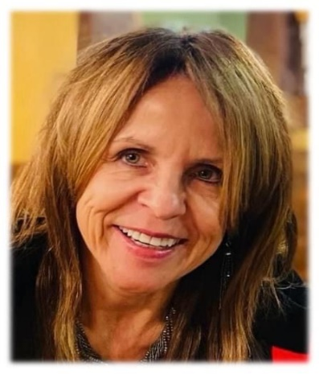usiness Development
Bio
Claire Sault was elected Chief on December 9, 2023, and served on the Missisaugas of the Credit Council through a bi-election since October 22, 2022. She formerly worked as the CEO of Northwind Business Development, a company wholly owned by Caldwell First Nation. Prior, Chief Sault served as the CEO for Kettle & Stony Point First Nation Administration with a large staff. During the Covid pandemic, Ms. Sault worked in a consulting capacity and prior to that, served as CEO of Noozhoo Nokiyan Limited Partnership owned by the Mississaugas of Scugog Island First Nation. She was the President of a non-profit in California called Divine Choices and Vice President and Director of Human Resources for a large public company and its subsidiary called First American Trust. Both, in the United States.
She was born and raised on the Mississaugas of the Credit First Nation with deep roots and strong ties to her mother’s First Nation (Six Nations) as well.
After returning to Canada, she functioned in various consultative capacities including working with a First Nation in Saskatchewan. Prior to moving to the United States though, she gained experience within various Aboriginal agencies, including tourism, addictions treatment, First Nation governments and various service organizations.
As President of a non-profit and services company, from 2007 through 2013; she travelled extensively promoting the mission and cause of child sexual abuse prevention through public speaking engagements, social media, and TV commercials.
She’s also an author and co-author of various papers, teaching materials and a book called “The Lie That Binds”.
Ms. Sault received a master’s degree in business administration from Simon Fraser University with her focus on Aboriginal Business and Leadership.
Her background provides a broad expertise in business and financial management and more importantly, an understanding of the Indigenous way of life.
Ms. Sault is the second youngest of a large family and resides on the Mississaugas of the Credit First Nation.

